**Buffering**

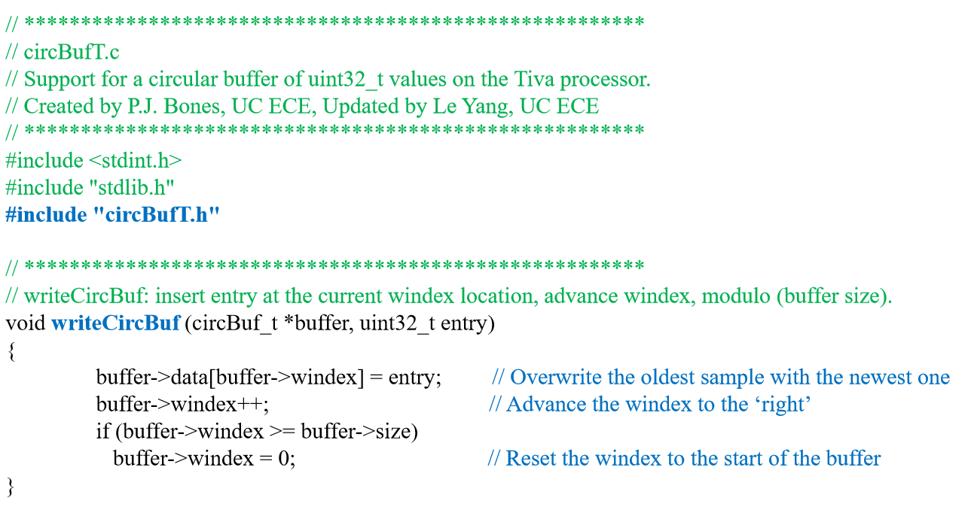circBufT.c

ADCdemo1.c

In the initialization section of the program before the infinite while loop:

* Initialize Circ Buffer so can wright and read from it = **initCircBuf** (&g_inBuffer, BUF_SIZE);

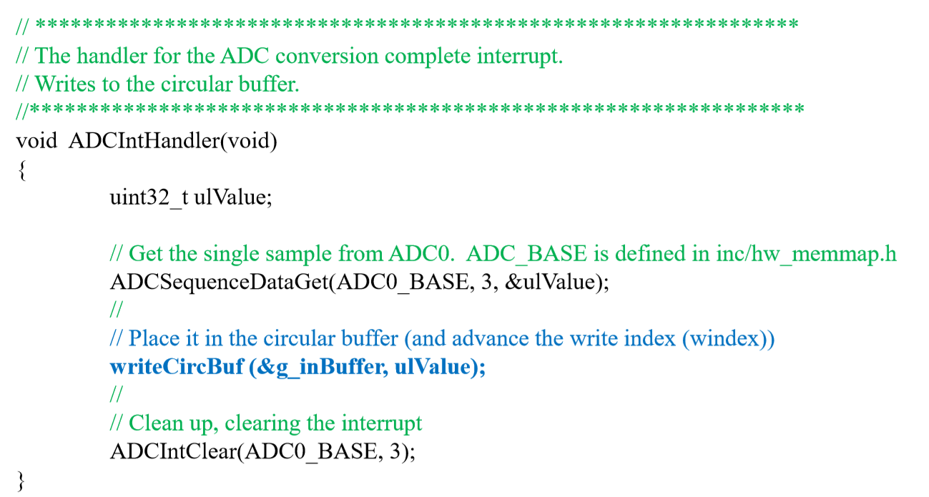

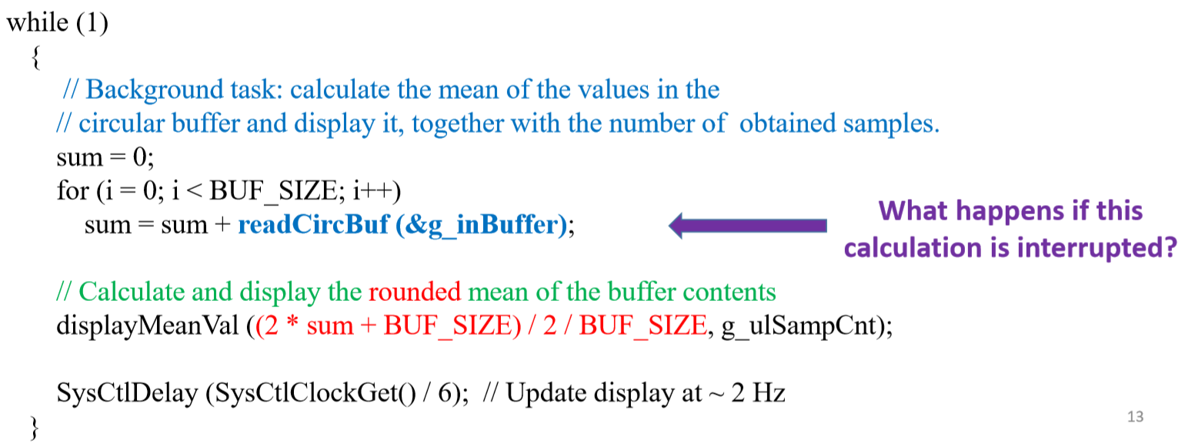

Buffer is still read from